FALL 2024  
MEC723: MECHANICAL SYSTEMS DESIGN  
DESIGN PROJECT  
**MILESTONE REPORT 2**

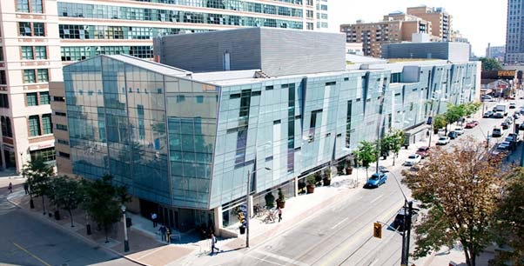

TITLE OF PRODUCT

TEAM SSNN

# team declaration

We, the undersigned members of Team SSNN in MEC723, agree that all team members have abided by all Ryerson Policies and course rules.

We furthermore accept that any violation of Ryerson Policy or course rules will lead to a grade penalty or charges of academic misconduct.

| STUDENT NAME | STUDENT NUMBER[1] |
| --- | --- |
|  |  |
|  |  |
|  |  |
|  |  |
|  |  |
|  |  |

# 

# executive summary

Text

# heading (tbd by team)

Text

1. Only the last 5 digits of the student number are required.